I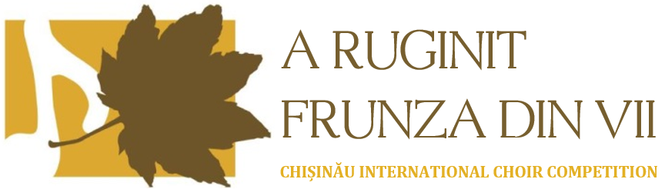
XIX-th Edition. Chișinău, Republic of Moldova. October 15-18, 2026

st^{th}2023

Name of choir:

Name of conductor:

Address:

Phone number: Fax:

E-mail: Website:
Sections you would like to participate (you can select both): Competition Festival
Categories: Children’s’ Choir (A): Youth Choir (B)
Mixed choir (C): Chamber Choir (D): Vocal ensemble (E):

Total number of members F M
Scores performed in the „Contest” category, in order of performance (#5):
Composer Title Year Duration

Scores performed in the „Festival” category, in order of performance (#4):
Composer Title Year Duration

Does your performance require instruments? Yes No
If yes, please specify: ___________________

Date Signature/Name of conductor

